Navigation

Exercise #01

Flutter Developer Bootcamp

# **Purpose**

This Exercise defines a Flutter screen for user signup. It includes input fields for name, number, and password, along with buttons for signup and social media login.

# **Problem**

The Flutter Exercise defines two classes: home and Notification Screen. The home class represents a home screen with a notification button that navigates to the Notification Screen. The Notification Screen class displays a list of notifications.

# **How to Solve**

1. Checkout the workshop from Git Repo:

git clone -b <user-branch> <repo-URL>

2. Open the root folder inside VS Code

3. To build the app click the run option in the main method { }

4. **AppBar**:

* Define an app bar with an action button for navigation.

**5. Images**:

* Display a list of images in a column below the app bar.

**6 NotificationScreen Class**:

* Define a stateless widget called Notification Screen.
* Constructor has no properties.
* Override build method to define UI for notification screen.

**7. Notification Screen UI**:

* Return a Scaffold widget with app bar and body containing a ListView of notification items represented by ListTile widgets.

# **You Will Achieve**

By implementing the provided Flutter Exercise , you'll achieve a basic mobile application with two screens:

### **Achievement:**

* **Home Screen**:
  + Displays a title "Home" in the app bar.
  + Shows a list of car images.
  + Includes a button to navigate to the notification screen.
* **Notification Screen**:
  + Presents a list of notifications.
  + Each notification can be deleted individually.

This achievement represents a fundamental structure for a Flutter application with navigation and basic UI components.

# **Screenshots**

## **Expected Output**

 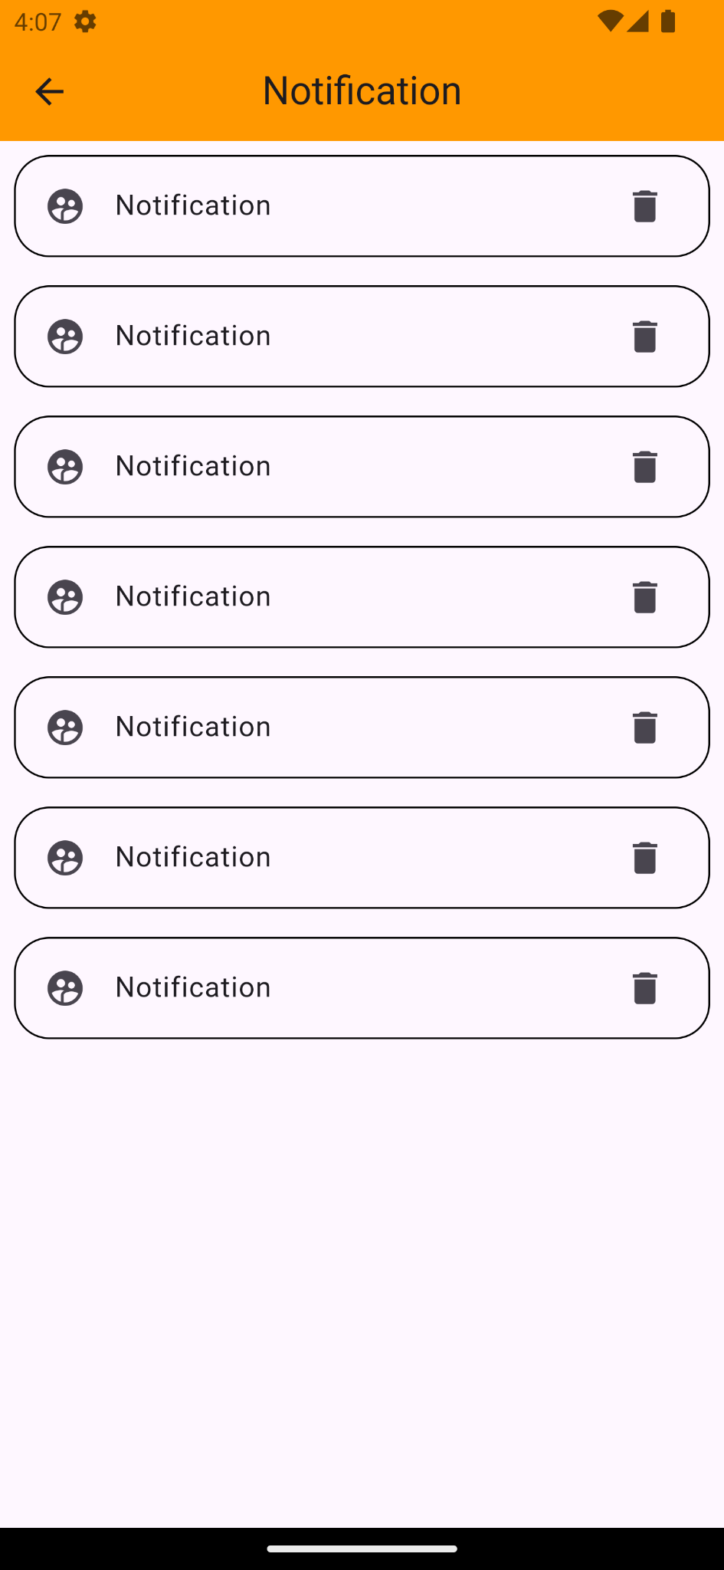

# **How to submit your Exercise**

Push your project back to the same git branch using command:

<command name>

# **Happy Coding!**